**B and O type flare notes**

* A class of massive X-ray binaries, transient x-ray sources associated with O and B type stars which are characterized by short outbursts
* Supergiant fast x-ray transients (SFXTs) are different from classical high mass x-ray binaries (HMXBs) with supergiant companions, which are bright persistent sources. [1]
* Outbursts from SFXTs range from a luminosity of 1032erg s-1 (10x1025 W) to a peak luminosity of 1037erg s-1 (10x1030 W)
* Outbursts last a few days and consist of many short outbursts which last a few hours each [1]
* SFXTs can also display a faint flaring effect with luminosity, LX = 1033 – 1034 erg s-1 (1027 – 1028 W) [1]
* One proposition of SFXT outbursts is due to the presence of an equatorial wind component which is denser and slower than the symmetric wind from the supergiant. In the framework of this wind accretion, “the X-ray luminosity depends on the wind mass loss rate, Mw, and on the relative velocity, νrel, of the neutron star and the wind”[2]
* Another proposition involves gated mechanisms which are due to transitions across the centrifugal barrier (centrifugal or magnetic barrier can explain SFXT properties if the supergiant wind is inhomogeneous)
* In the framework of the clumpy wind model proposed by Oskinova, Hamann and Feldmeier, (2007) [3] they proposed that SFXTs differ from HMXBs with supergiant companions by their different orbital separation. In persistently bright sources (HMXBs), the compact object orbits the companion at a distance of around 2 stellar radii (with high number density of clumps). Whereas “the transient emission in SFXTs is produced by accretion of much rarer clumps present at larger distances” [1].
* If the total mass of the star decreases (via mass loss) then the number of flares decreases due to a reduction in the total number of clumps, and the average luminosity of the flares is reduced due to the decrease in the number density of clumps [1].

[1]

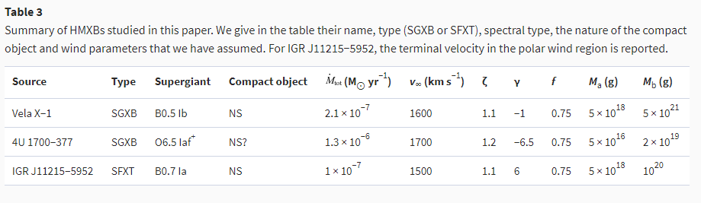

* Ultra-long gamma ray bursts (ULGRBs), duration of thousands of seconds (about two orders of magnitude larger than that of standard Long GRBs (LGRBs)
* A possible endpoint of stellar evolution of BSGs, due to the long free fall timescale of their envelopes, which allows accretion to power a long-lasting central engine [4].

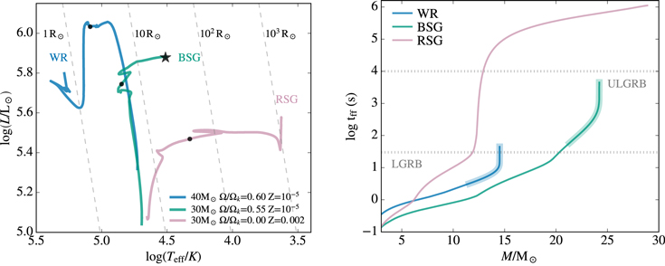

Figure . Left: HR-diagram showing thee volution of three massive stars from the zero- age MS to core collpase, calculated with MESA. The BSG (teal line) has a Mini = 30 solar masses, metalicity, Z = 10-5 and an initial roation rate = 0.55. Right: freefall timescale as a funciton of mass coordinate for the three models shown in the left panel. [4]

* Left figure shows BSG does not evolve fully chemically homogeneously, its envelope experiences a large degree of mixing which keeps the star blue whilst preserving the envelope with a radius of a few tens of solar radii
* Dot shows where He burning begins contributing substantially ( 90% of solar luminosity)
* Right figure shows how the BSG model accretion timescale is comparable with ULGRB durations, whilst WR model is consistent with LGRB durations (dotted lines)

Free fall time scale:

$t_{ff}=\frac{1}{\sqrt{24πG\overline{ρ}}}$ [4]

Where:

$\overline{ρ}$ = average enclosed stellar density for a given stellar model at core-collapse

$G=gravitational constant$

WR stars have a typical tff of 10s of seconds where BSGs have a tff of 10,000s of seconds [4]

* “At core collapse, such a BSG model can produce an accretion disk around a newly formed central object with an accretion timescale = 104s.” [4]

References

[1] Ducci, L et al., 2009. The structure of blue supergiant winds and the accretion in supergiant high-mass X-ray binaries. *Monthly Notices of the Royal Astronomical Society*, [online] 398(4), pp.2152-2165. Available at: <https://academic.oup.com/mnras/article/398/4/2152/983687> [Accessed 12 February 2021].

[2] Sidoli, L., 2009. Transient outburst mechanisms in Supergiant Fast X-ray Transients. *Advances in Space Research*, [online] 43(9), pp.1464-1470. Available at: <https://www.sciencedirect.com/science/article/pii/S0273117709001410?via%3Dihub> [Accessed 12 February 2021].

[3] Oskinova, L., Hamann, W. and Feldmeier, A., 2007. Neglecting the porosity of hot-star winds can lead to underestimating mass-loss rates. *Astronomy & Astrophysics*, 476(3), pp.1331-1340.

[4] Perna, R., Lazzati, D. and Cantiello, M., 2018. Ultra-long Gamma-Ray Bursts from the Collapse of Blue Supergiant Stars: An End-to-end Simulation. *The Astrophysical Journal*, 859(1), p.48.